Wood Lawn

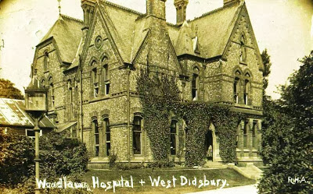

Woodlawn was one of those very big houses that Didsbury used to excel at.

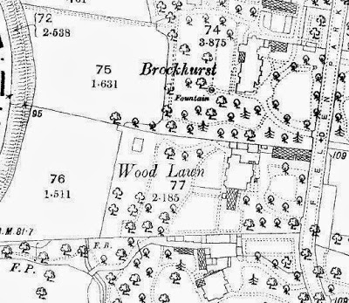
It stood on what was Fielden Park and is now Mersey Road which runs from Palatine Road up to Barlow Moor Road.
It had fifteen rooms, was set in extensive grounds which ran down towards the Mersey and was flanked by the even more impressive houses of Brockhurst to the north and Mersey Bank to the south, both of which commanded even bigger gardens and both of which had their own fountains.

Now I can’t be sure exactly when it was built but it was there by 1891 when it was the home of James and Rosamund Halliday.

He was an accountant and partner in a number of firms including Deloitte and Halliday with offices at Queen Elms on High Street and on Oxford Street and later described himself as a banker.

Born in Scotland he was here in Manchester by 1861. We can track him from Chorlton on Medlock to Broome House in Didsbury where the family were living in 1881. And like so many of the other residents of Broome House they went on to bigger and better homes which in the case of the Halliday’s was Woodlawn.

There is no doubting that this was an impressive property. He died in 1913 and this will have been when Mrs Laura Churchill bought the property and a year later offered it to the Red Cross as a hospital at the start of the Great War.

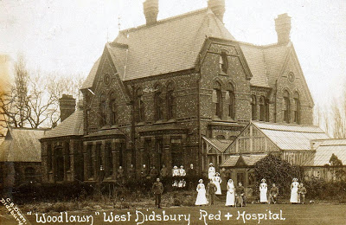

You reached it by a tree lined drive with paths off across the gardens down towards the river and past a series of large greenhouses.

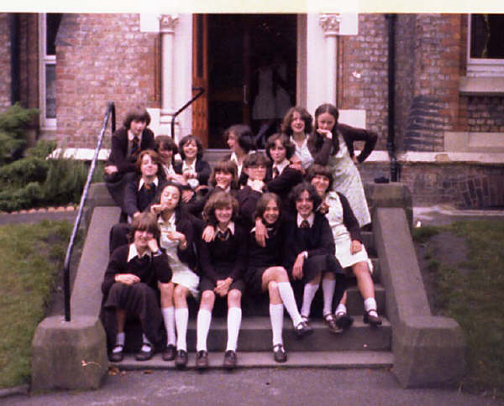

The house was built on a raised bank which meant the entrance up to the front door was by way of a set of stone steps.

Looking at the pictures of the place you have to admit that it was a solid and magnificent place which befitted a banker. The house was demolished I think in the 1990s
post script
Woodlawn was part Part of The new Hollies convent and school when they moved from Oak Drive in Fallowfield. I was there from 1949 to 1958, my sister and daughter followed.
I loved every moment, the buildings fed my love of grand houses even though they took a bit of a battering from us girls.

