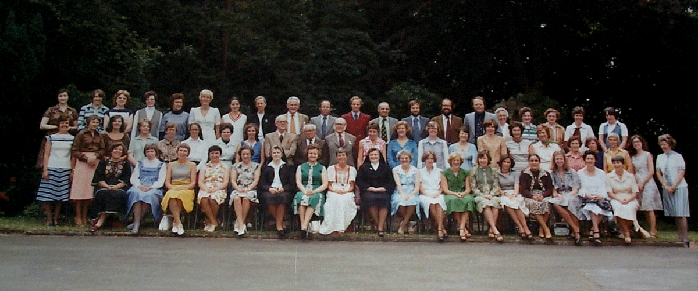

Names for the staff photo 1977 are as follows

Left to right:
Top row:
Miss Frances Chamberlain,RIP (music); Mrs.Murphy?(lab.asst);
Mrs.MacDonald (history); Mrs.Agnes Harrison (librarian); Miss Joan
Reynolds(secretary); Miss Janet Rigby (geography); Mme.Genevieve
Adams(French); Sr.Mary (geography); Dr.Dennis Quirke (biology); John Flynn
(maths); Peter Arnfield (music); Norman Finley (geography); Archie McDowell
(maths); Mike Bethell (physics); Paddy Barrett (religion); Sr.Columba
(French); Mrs.Maureen O'Donohue,RIP (history); Miss Marie Kiernan (history);
Mrs.Barbara Jones (Latin); Pat Rowan (lab.asst.)
Middle row:
Mrs.Rita Stanhope (maths);Mrs. Mary Mallik (English);
Mrs.Geraldine Stevenson (English); Mrs.Angela Trueman (English); Miss Fiona
Stuart (English); Sr.Rosemary (French); Mrs.Gwen Ward (secretary); Mrs.Sheila
Harkin (French); Mr.Richards (Bursar); Mr.Batty (violin); Mr.Edwards,RIP
(music); Miss Pauline Smith (history); Mrs.Elaine Maybury,RIP (art); Mrs.Ann
Taylor (biology); Mrs.Mary Pleeth (chemistry); Mrs.Ro Kaye (physics); Mrs.Eve
Carr,RIP (Domestic Science); Mrs.Margaret Bradbury (maths);Mrs. Molly Finley
(secretary); Mrs.Farrell (secretary); Mrs.Kate Gill (English); Miss Mary
Davenport (geography);Miss Marie O'Brien (P.E.)
Bottom row,seated:
Mrs.Norah Garbutt,RIP (elocution); Miss Ann McGough (art);
Mrs.Anne Hemmings (British Government); Miss Pat Delaney (Domestic Science);
Miss Marie Furphy (English); Reverend Mother;Miss Doreen Pugh,RIP (Deputy
Head, classics);Mrs. Valerie Nicholson (chemistry); Sr.Victoire Headmistress;
Miss Yvonne Kalpakdjian,RIP (French);Miss Anne Fitzsimmons (Spanish); Jill
Hodgkinson (P.E.);Miss Rosemary France (German);Mrs. Susan Carroll,RIP
(Science); Mrs.Agni Ionnades (maths);Mrs. Liz Hill (maths); Mrs.Sylvia
Bradley (classics);Mrs. Nina Orlowski (Spanish).

